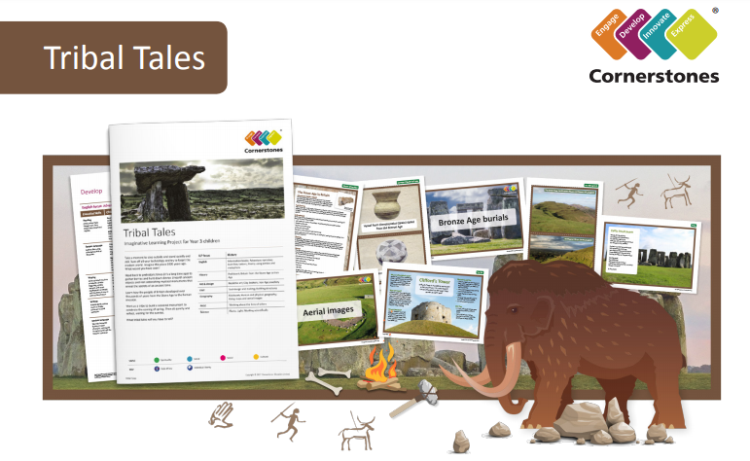

Let’s travel back to prehistoric times! This half term we’re going to learn about the Stone Age, the Bronze Age and the Iron Age. What were people’s daily lives like and what epic battles did they fight? Using techniques such as cutting, moulding and mark making, we’ll make Iron Age jewellery. We’ll look closely at cave paintings and create our own. In Science, we will learn about light and as we learn about the Bronze Age, build monuments and investigate their shadows. Then, we’ll travel to the Iron Age to learn about hill forts and the properties of iron.
At the end of the ILP, we’ll present our favourite era from the Stone, Bronze or Iron Age!
ILP Focus | History
English | Poetry
History | Prehistoric Britain from the Stone Age to Iron Age.
Art & Design | Cave Paintings, Iron Age Jewellery
Science | Light
PHSE | Thinking about lives of others.



