Year 2 | Autumn Term 1 | Autumn Term 2 | Spring Term 3 | Spring Term 4 | Summer Term 5 | Summer Term 6
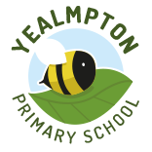 | 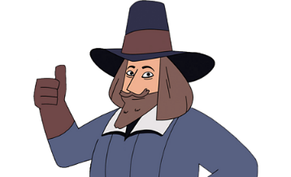 | 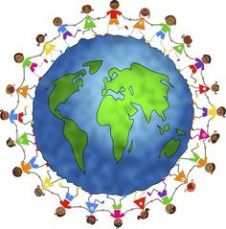 | 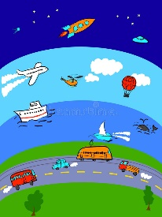 | 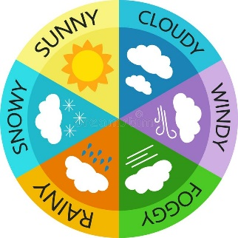 | 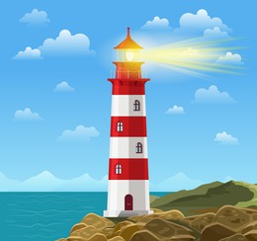 | 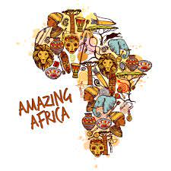
 | Gunpowder! | Our Wonderful World | On the Move! | Whatever the Weather | Land Ahoy! | Amazing Africa
Science | Materials and their uses | Living Things & Their Habitats | Animals including humans |  | Plants
Geography |  | What is a continent? |  | How does the weather affect our lives? |  | What would it be like to live in Africa?
History | Why was Guy Fawkes a significant history maker? |  | How has transport changed over time and which important people have influenced this? |  | Why do we remember Grace Darling?
DT |  |  | Wheels and axles- Moving Vehicles |  | Food – Healthy sandwiches for Mr Grinling | Sewing – African Puppets
Art | Expressive Painting | Making Birds |  | Explore & Draw
PSHE | Being Me | Celebrating Differences | Dreams and Goals | Healthy Me | Relationships | Changing Me
RE | Who is a Muslim and how do they live? | Why does Christmas matter to Christians? | Who is a Muslim and how do they live (part 2)? | Why does Easter matter to Christians? | What is the good news Christians believe Jesus brings? | What makes some places scared to believers?
Computing | What is a computer? | Word Processing | Programming | Algorithms and Debugging | International Space Station | Stop Motion
Music | Hands, Feet, Heart |  | I wanna play in a band | Zootime | Friendship Song | Djembe Drumming
PE | KS1 Games 3  Football | KS1 Net and Wall  Gymnastics | Gymnastics  KS1 Games 4 | OAA  Dance | Dance  KS1 Athletics 1 | KS1 Athletics 2  Cricket

