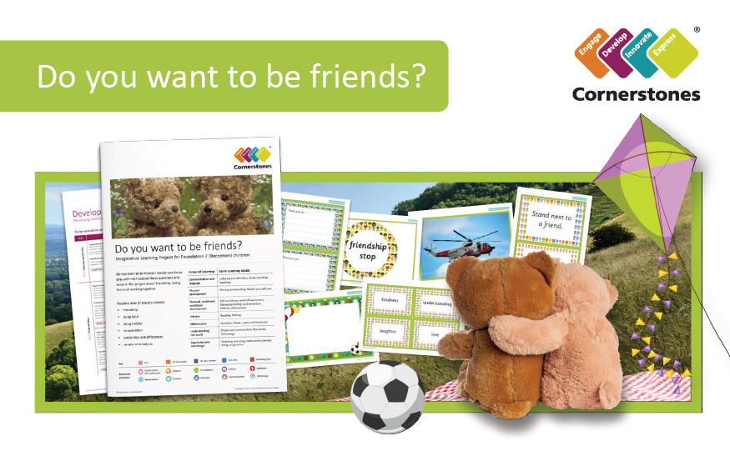
Friends are the family you choose! Do you want to be friends? Would you like to play with me? It’s time to find out more about friendship, being kind and working together.
During this topic, we will be finding out lots about each other, making new friends and exploring our new classroom and school.
Areas of Learning | Topic Overview
Communication and Language | Listening to others  Asking questions  Sharing ideas
Physical Development | Moving in and out of spaces  Ball skills  Fine Motor activities
Personal, Social and Emotional Development | Making friends  Things that are special to us  Jigsaw – Being Me in My World
Literacy | Phonics Phase 2 – Individual letter sounds  Blending sounds to read words  Segmenting words into sounds for writing
Maths | Numbers and Place value to 5
Understanding the World | People who help us  Outdoor learning
Expressive Arts and Design | Self portraits  Collage  Salt dough hearts

